I started following the instructions from this link

https://facebook.github.io/react-native/docs/getting-started.html

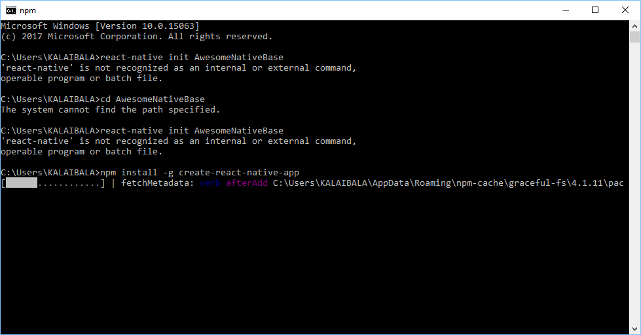

Installation done

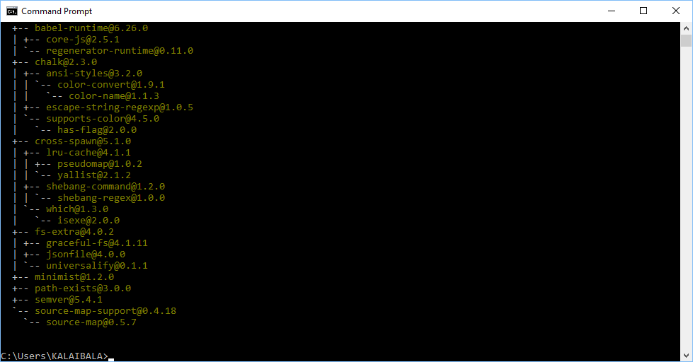

Create project

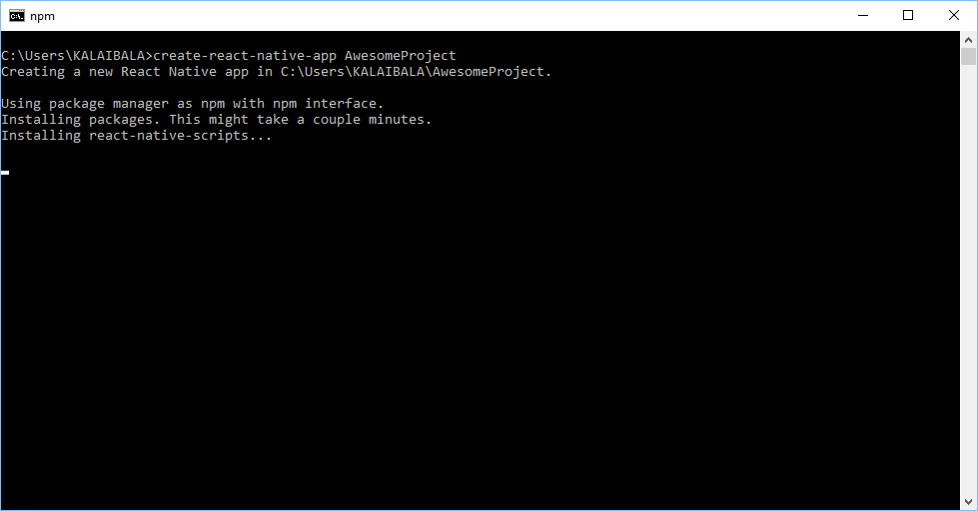

Once the above command executes (takes over 5 minutes), you get the below screen

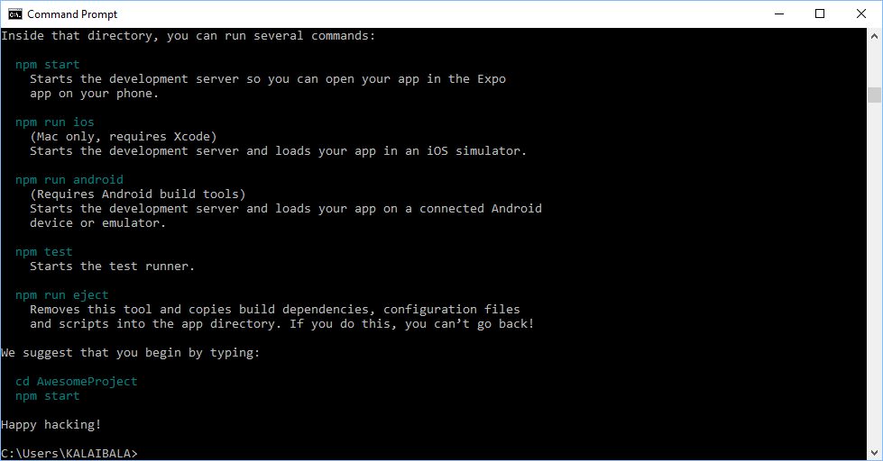

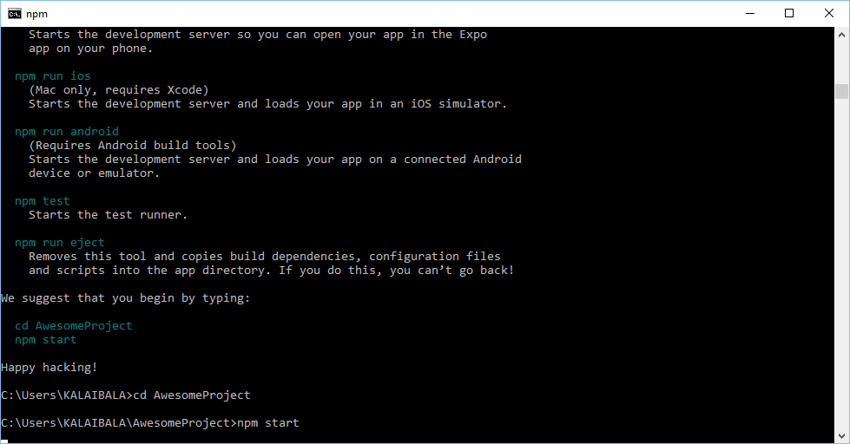

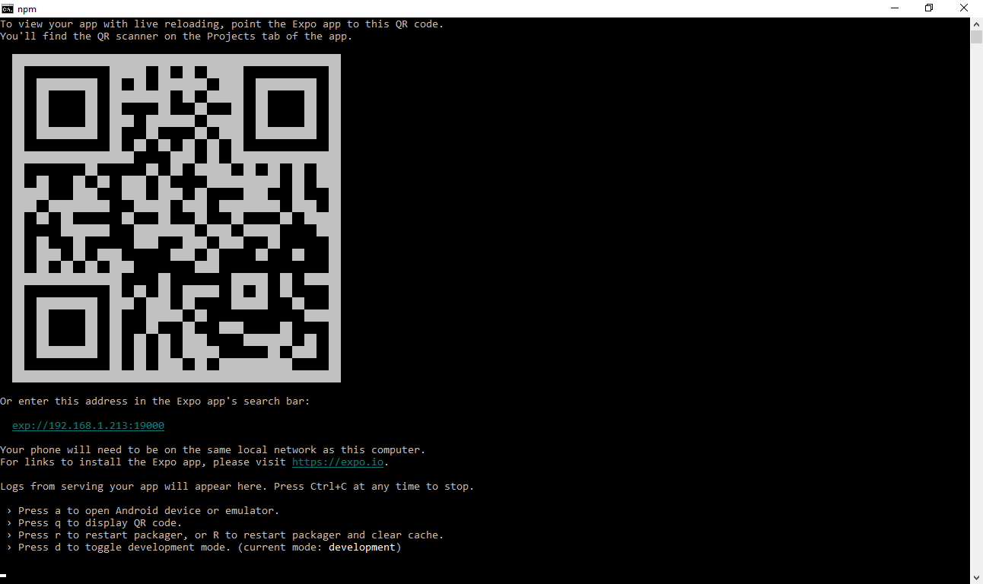

Install the expo client app on your IOS or Android phone, as per the instructions in the link.

The app loads on the phone (make sure the phone and the computer are connected to the same network).

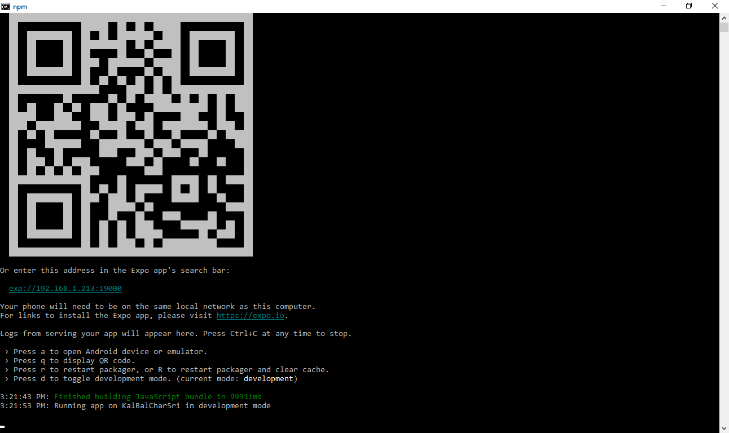

Now, install native-base (instructions in this link http://docs.nativebase.io/docs/GetStarted.html)

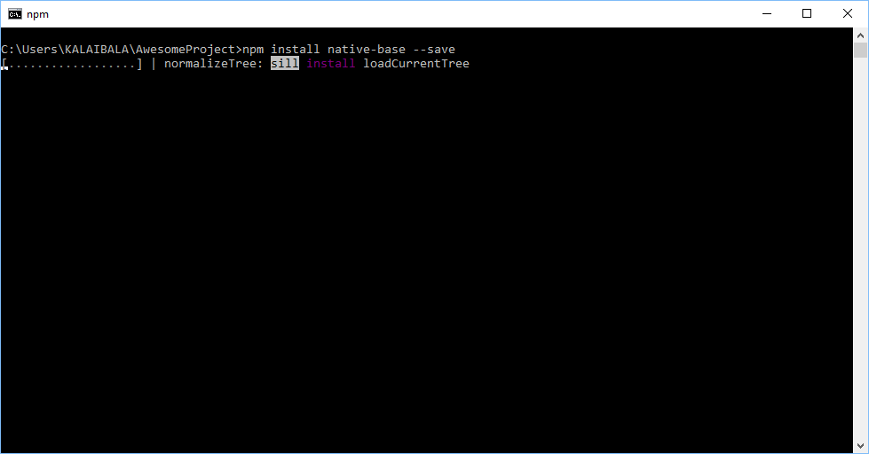

Installation looks like this…\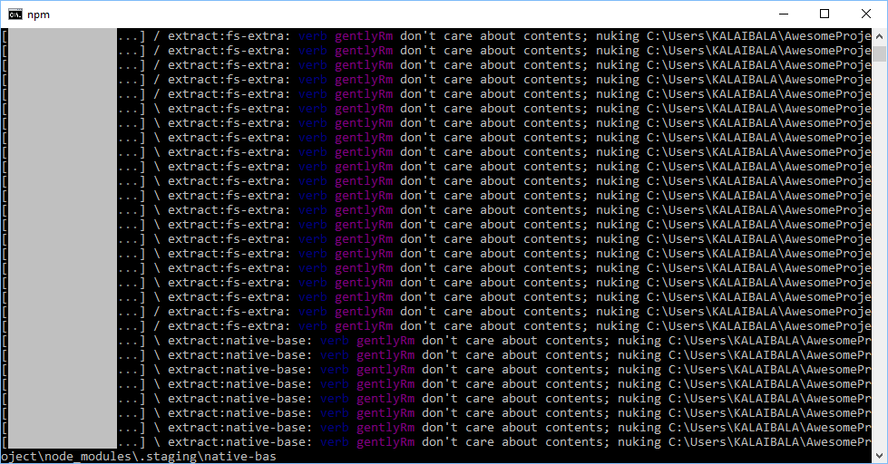

Installation done

